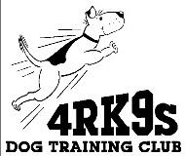

4RK9s Dog Training Club LIABILITY DISCLAIMER for non-club member presenters/trainers

I acknowledge that I have been told by 4RK9s that 4RK9s insurance will not be in effect for my coverage at

4RK9S Training Building
910 2nd Avenue SW, Suite A
Cedar Rapids, IA 52404

during my presentation/instruction at that facility.

______________________________________ ____________
Signature Date

