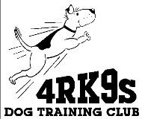

4RK9s Dog Training Club
910 2nd Avenue SW Ste A
Cedar Rapids, IA 52404

Include a copy of your latest vaccination certificates for BOTH rabies and distemper shots from
veterinarian.

LIABILITY WAIVER
I agree by my signature to hold 4RK9’s, its members, directors, officers, the owner of the premises used for training, and any party or employee of the aforementioned parties, harmless from any claim or loss which may be alleged to have been caused directly or indirectly to any person, animal or things by this dog while in or upon the premises or near the entrance thereto.

I personally assume all responsibility and liability for any such claim. I further agree to hold aforementioned parties harmless for any such claim for the loss of this dog due to disappearance, theft, damage or injury or any other causes. I am solely responsible for my children’s safety and welfare as well as their supervision during the entire time they are present on the training grounds.

To the best of my knowledge this dog is free of any contagious or potentially contagious diseases.

Signature:______________________________________Date:_________

