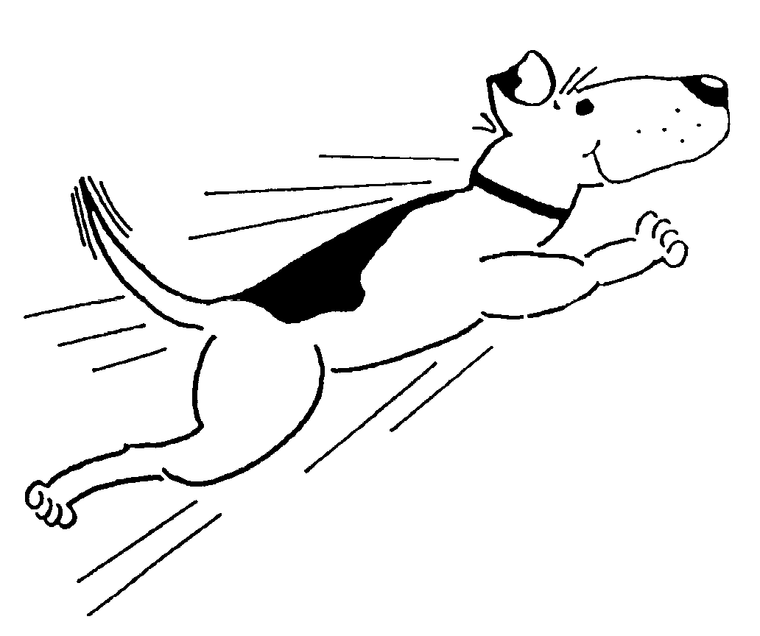 4RK9s Dog Agility Club
Membership Application Form

Name ____________________________________________ Application / Renewal Date: ___________________
Address _________________________________________ City __________________ State _____ Zip ________
Phone (_____) ________________________ E-mail Address ___________________________________________
Occupation ______________________________ Work Phone (optional) (______) _________________________
** If filing a RENEWAL application, skip to “jobs” interested in. **
What levels of obedience training have you completed / titles earned? _____________________________________
What levels of agility training have you completed / titles earned? ________________________________________
What breed(s) of dogs do you own / train? ___________________________________________________________
What are your goals with your dog(s)? ______________________________________________________________
What are your goals with the club (how would you like to contribute)? ____________________________________
_____________________________________________________________________________________________
Are you or have you ever been suspended/fined by any national dog club? ____ No ____Yes
Have you ever been convicted of a felony offense? ______No ______Yes
If yes, explain: _________________________________________________________________
Annual Fee: $30 Single $10 Junior (Age 8-18)

Club Sponsors (only Active Members with at least one year membership are eligible to be sponsors)
Signatures: (1) __________________________ (2) _________________________ (3)___________________________

Please check three of the following “jobs” you are interested in learning about and/or doing for the club:
___ administration ___ stewarding ___ fun match committee
___ teach obed/agil classes ___ training coordinator ___ trial chairperson/co-chair
___ class coordinator ___ hospitality ___ building maintenance/cleanup
___ equipment maintenance ___ publicity ___ other: __________________________

I agree to abide by the By-Laws of this club. Signed: __________________________________________
Any misleading information shall be subject to immediate dismissal.
Office use:
Date of Initial Meeting: ___________________ First reading: ___________________ Second reading:_____________________
Mail this form along with first year’s annual fee to:

Membership Secretary, 910 2nd Ave SW, Cedar Rapids, IA 52404

